Professional Resume

For

Gunnery Sergeant Mark J. Koerner

t

UNITED STATES MARINE CORPS

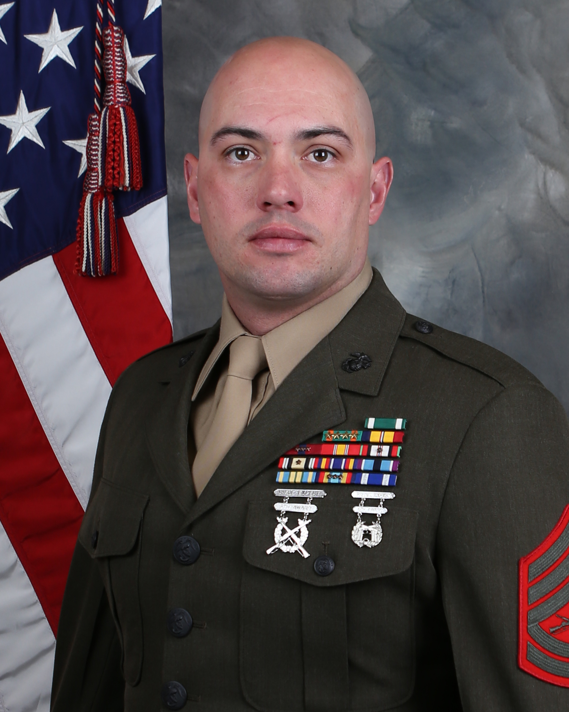
2005 Recruit Training
2005 School of Infantry
2005 NBC Monitor/Survey/Decon Course
2005 Combat Aidsman Course
2006 Machine Gun Leaders Course
2006 Urban Assault Leaders Course
2006 FBCB2 Operators Course
2006 Blue Force Tracker Operation Course
2007 Sergeants Distance Education Program
2008 Bachelor Enlisted Housing Ops and Mngmnt Course
2008 SNCO Distance Education Program
2009 Combat Marksmanship Coach
2009 Combat Marksmanship Trainer
2009 Basic Instructor Skills Course

2010 Substance Abuse Control Officer Course
2010 Associate of Arts, University of Phoenix
2012 SNCO Advanced Distance Education Program
2012 Watch Officer/Watch Chief Course
2012 Senior Enlisted Non-Resident Joint PME
2013 Infantry Unit Leaders Course
2013 Leading Marines Distance Education Program
2013 Lee Parks Level II Motorcycle Mentor Course
2013 Infantry Company Small Boat Raid Course
2014 Combat Instructor School
2015 SNCOA Career Course
2016 SNCOA Career Course Distance Education Program
2017 Foreign Weapons Instructor Course

EDUCATION (CIVILIAN & MILITARY)

Personal Information
Date of Rank: 161002
Wife’s Name: Abby J. Koerner
Children: None

Combat Instructor Trainer/Academics Coordinator
Combat Instructor School, SOI-West
PO Box 555081
Camp Pendleton, CA 92055
Comm. (949) 606-3959
Email: mark.koerner@usmc.mil

CHRONOLOGY OF ASSIGNMENTS
0410 - 0504 Recruit Training San Diego/SOI West Recruit/Student
0504 - 0801 2d Battalion 5th Marines Company E Machine Gunner/Squad Leader/Machine Gun Section Leader
0801 - 0810 HQ Company 5th Marine Regiment Barracks Manager/Company Gunnery Sergeant
0810 - 1109 WPNS CO 1st Battalion 24th Marines I-I Training Chief/Operations Chief/SACO/Funerals NCOIC
1109 - 1210 2d Battalion 5th Marines HQ Co S-3 Watch Chief/Assistant Operations Chief
1210 - 1407 2d Battalion 5th Marines Company F Rifle Platoon Sergeant
1407 - 1409 Combat Instructor School/SOI-West Student
1410 - 1507 Delta Co, ITB/SOI-West Combat Instructor/Platoon Commander
1507 - 1604 Alpha Co, ITB/SOI-West Combat Instructor/Platoon Commander
1604 - 1612 Combat Instructor School/SOI-West Combat Instructor Trainer/Squad Advisor
1612 - Present Combat Instructor School/SOI-West Combat Instructor Trainer/Academics Coordinator

MAJOR AWARDS & DECORATIONS
Navy and Marine Corps Commendation Medal (2nd Award)
Navy and Marine Corps Achievement Medal (5th Award)
Combat Action Ribbon
Outstanding Volunteer Service Medal
2016 USMC Combat Instructor of the Year

COMBAT TOURS
0306-1006 OIF 6-8
0212-0912 OEF 12-1/2

